 SHENZHEN HELILAI TECHNOLOGY CO.,LTD
Add:Helilai LED group industrial park,changfeng Rd,changzhen village,gongming town,guangming new district,shenzhen city,China.
Contact:Aisa Moble phone:+86 18676738905 wechat:18676738905 skype:ledhll22 Email:ledhll@163.com www.hll-leddisplay.com
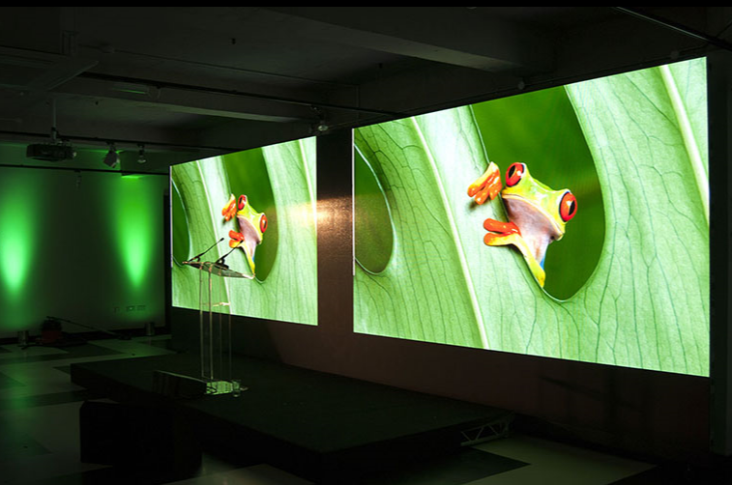

P2.5 led display details information
Product: P2.5 indoor full color
Module size: 160*160mm
Pixel density: 160000 dots/m²
LED lamp: SMD2121
Module resolution: 64*64
Module consumption: 30W/piece
Viewing distance: 3-15m
Max power consumption: 1200W/m²
Standard cabinet size: 480*480mm
Drive mode: 1/32 scan
Brightness: 1200-1500cd/m²
Hub mode: hub75
Drive IC: MBI5124
Frame frequency: ≧60Hz/s
Refresh rate: 360-1920Hz/s
MTTF: >5000 hours
Life time: >100,000 hours
Defect rate: <0.0001
Video signal input: RF, S-video, RGB, RGBHV, YUV, YC, composition
Temperature range:Storage: -20 to 65°C
Working: -20 to 50°C
Gray scale/color: 4096 grades for R ,G and B
Display: ≥16.7m colors
Working voltage: 110/220V AC
Viewing angle:
Horizontal: 120º
Vertical: 120º
Display content: videos, pictures and graphics
Operating humidity: 10-90%
Storage humidity: 10-90%
Continue working time: 24 hours
Controlmode:synchronization
Module price:18.68USD/PCS(with tax rate price)

